Chapter 3
3.1 Numbers on Computers and Numbers on Dedicated Hardware: Fixed-Point Registers
Signed binary numbers can be represented and stored in different ways. Determining this representation is important because it decides how arithmetic is carried out. There are three main representations:
- Sign-Magnitude.
- One’s Complement.
- Two’s Complement.
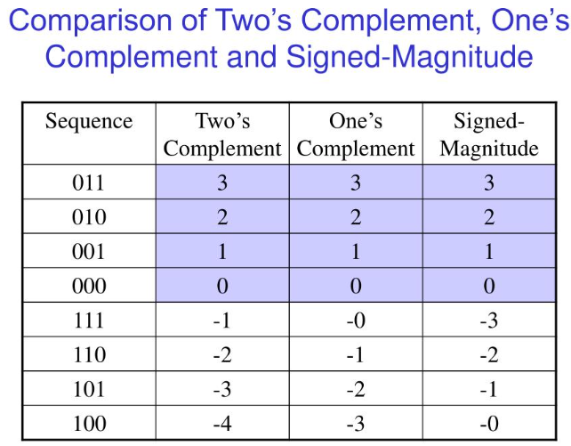
The “best” signed number representation is two’s complement. The big deal about two’s complement is not only that it is a more efficient representation that makes no “waste” in representing the zero with two representations as in sign-magnitude and 1’s complement, but also that it is friendly to arithmetic. We can mix positive and negative operands without any preprocessing or modification.
Another important decision about binary number representation is whether to store numbers as fixed point or floating point. El moshkela el asaseya fel floating point el bet5alena nesta5dem fixed point heya el floating-point arithmetic. El arithmetic fel floating point is not as simple as in fixed point, it requires much processing and much power. On the other hand, fixed-point arithmetic is very simple and requires no preprocessing or modifications for the operands. Tab3an floating point is more accurate as shown below, however we go with fixed point since it is simpler on hardware.
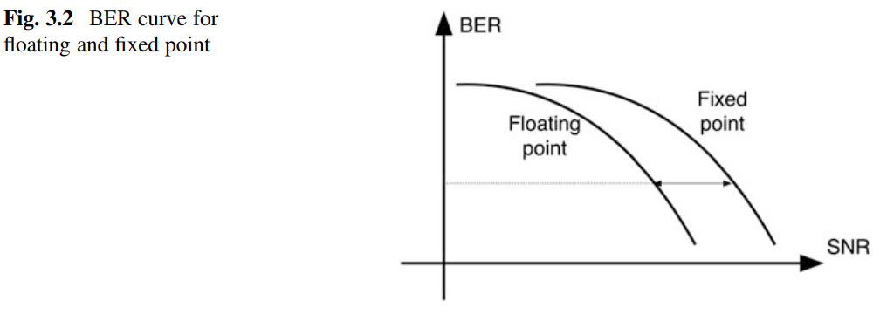

3.2 Modeling Fixed-Point Number Generation
Note abl ma nebda2: Fel goz2 da el doctor mohtam be eno ezay ne3mel fixed-point simulation 3la MATLAB el howa shaghal fi floating-point environment bema en el CPU bta3 el laptop shaghal floating point. Fa el doctor mesh mohtam be eno ye generate binary representation lel arqam w yetala3ha fi text files 3ashan yedeha lel RTL w keda, la2 howa bey seek ezay ne5la2 fixed-point environment gowa floating-point environment. Fa beyeshra7 ezay ye7awel floating-point number le fixed-point number ye get stored fi n bits. Y3ny enta 3la MATLAB m3ak floating-point number leeh tab3an infinite number of bits lel fractional part, 3ayez b2a el raqam da te5azeno fi 8 bits bs masalan. Tab3an e7na already shara7na fel GP ezay n3ml da be este5dam el built-in functions fi w fimath, laken el l doctor beye3melo hena howa eno beye3mel el generation da manually. Ana shayef besara7a enaha malhash lazma la2en el bel built-in functions bete3melena el e7na 3ayzeno fa 5alas y3ny. Kaman el doctor beyetkalem 3an ezay ne7awel arqaam mabeen 0 w 1 bs, mesh 2ayel ne3mel eh lw el arqam akbar men 1 aw lw el arqaam negative.
Delwa2ty e7na 3la MATLAB w m3ana arqaam kolaha floating point (i.e. leha infinite number of bits for the fractional part and hence infinite accuracy), w 3ayzeen ne7awel el floating-point numbers de le fixed-point numbers b7ees ne3mel fixed-point simulation 3ashan nshoof el accuracy el hateb2a f3ln 3al hardware. Tyb w y3ny eh n5ly el raqam 3obara 3an fixed-point? y3ny n5leeh 3obara 3an integer part w fractional part. Actually, el doctor beyeshra7 3la arqaam kolaha mabeen 0 w 1 w kaman unsigned, w bel taly el arqaam el han7awelha men floating-point le fixed-point kolaha 3obara 3an fractional part bs, mafeesh integer part. Eh b2a el procedure bta3 el ta7wela de? assume enena 3ayzeen ne7awel variable $a$ men eno floating-point number le fixed-point number met5azen fi $n$ bits bs. El procedure as follows:
a = rand;
a = a * (2^n - 1);
a = floor(a);
Eh b2a el 7asal hena? awel line de function bet generate random number in the range (0, 1). Fa assume a = 0.6324 masalan. Fa delwa2ty a da floating-point number, y3ny wa5ed theoretically infinite number of bits lel fractional part beta3o 3ashan yet5azen fi el memory beta3et el laptop, w bel taly howa leeh full precision, y3ny met5azen completely accurate fel memory. El raqam da ka fixed point representation me7tag ta7dedan 31 bits 3ashan ne5azeno kamel. Specifically, el raqam da in binary is represented as:
$$.1010000111100100111101110110011$$
Mesh mohem ana 3ereft el binary representation beta3o ezay, bs 3amaltaha bel fi object bta3t MATLAB 3amatan y3ny. El mohem, notice en el binary point 3al shmaal 5ales 3ashan zy ma olna el raqam hena 3obara 3an fractional part bs. Fa e7na tab3an mesh 3ayzeen ne5azen kol el bits de, e7na 3ayzeen ne5azen 8 menhom bs. Yeb2a e7na 3ayzeen na5od 8 bits menhom bs ne5azenhom fel memory bta3t el laptop wel ba2yeen nermehom. De nefahemha le MATLAB ezay? 3an taree2 tany w talet lines dool. Hana5od el raqam $a$da, el howa el binary numbers el keteer el fatet de, w nedrabo fi $2^8$. Keda e7na 3amalna eh? keda e7na 7arakna el binary point as follows:
$$10100001.11100100111101110110011$$
Tab3an enta fi MATLAB lw geet tshoof el value beta3t $a$delwa2ty mesh haygeblak el binary representation el faat da, haygeblak el decimal value beta3to, el heya hena $161.8944$ (garab 7awel el raqam el faat da le decimal hatla2eh keda f3ln). Hal e7na yehemena raqam $161.8944$da nafso fi 7aga? la2 e7na mohtameen bel binary representation beta3o bs. El mohem, eh el 5atwa el b3d keda? en enta b2a termy el fractional part bta3 el raqam da. Y3ny t5ly el raqam yeb2a 3obara 3an:
$$10100001.$$
El howa lw geet te2rah ka decimal hatla2eh $161$, tayarna el fractional part y3ny. Tab w 3amalna el 7araka de ezay? howa da el line el talet, el howa el flooring. Fa delwa2ty keda el met5azen fel memory howa $10100001.$w lw geet tbos 3al value fi MATLAB hatla2eha $161$. Eh da sawany ana kont 3ayez a5azen $0.6324$meen $161$da? ah manta 5aly balak enak bs me7tag teraga3 el binary point fi makanha tany, heya etna2let lel a5er. Fa te2dar ta5od b2a el raqam el faat da w te3melo divide $2^8$ tany hatla2eh b2a keda:
$$.10100001$$
El howa lw 7aweltaha decimal hatla2eh $0.62890625$. Tab3an bayen en fih shwayet approximation besabab el bits el ramenaha de. Bs 5alas e7na keda 5alasna w 5azena el raqam fi 3adad el bits el e7na 3ayzeno. El 7aga bs el ghareba el wa7eda en tela7ez en line 2 fel code kan $2^{n}-1$ mesh $2^{n}$. Howa ta2reban el doctor 7atet el minus 1 de 3ashan lw el rand tala3et $1$fa lw darabnah fi $2^{n}$ keda mesh hane3raf ne5azen el $2^{n}$ fi $n$bits y3ny, bs anyway y3ny el minus 1 da mesh hayefre2 keteer.
The most important note to keep in mind is that you can’t carry out an operation between two registers unless they have the same scale.

3.3 Fixed-Point Addition
Adders increase the word length of the output by 1 relative to the operands. You have three options to deal with this:
- Store the result of n-bit adders in n + 1 bit registers. This is often a good solution for adders since 1 bit is not a big deal.
- Drop the MSB of the result and store the remaining n-bits. This can lead to an overflow. This is a practical option only for floating-point adders.
- Drop the LSB of the result and store the remaining n-bits. This leads to quantization noise.
Note: overflow is a failure of the adder, while quantization noise is just a loss of accuracy of the adder.
Example:
$$1111+1111=11110-throw MSB→ 1110$$
$$15+15=30-throw MSB→14$$
This is a failure due to overflow, the stored value is $14$rather than $30$.
$$1111+1111=11110-throw LSB→ 1111$$
$$15+15=30-throw LSB→ 15$$
However, this is not an incorrect result. Why? because when we threw the $LSB$, we implicitly shifted the result to the right by a single bit, thus dividing by 2, which means we changed the scale of the number. Thus, to truly calculate the error due to truncation, we return the number again to the original scale by multiplying it by 2. Thus, the error is $30-15*2=0$, so there is no error. Another example:
$$1111+1110=11101-throw MSB→ 1101$$
$$15+14=29-throw MSB→13$$
This is a failure due to overflow, the stored value is $14$rather than $29$.
$$1111+1110=11101-throw LSB→ 1110$$
$$15+14=29-throw LSB→ 14$$
Error is $29-14*2=1$.
Thus, truncation does not occasionally make the number wrong as in the case of overflow. Instead, it occasionally makes the result “noisy” by truncating a significant LSB. Through simple inspection, we deduce that even results will never be noisy when truncated, while odd results will always have an error of 1.

3.4 Fixed-Point Multiplication and Managing Wordlength Growth
For multipliers, the only viable option is to drop bits from the LSBs as shown below:
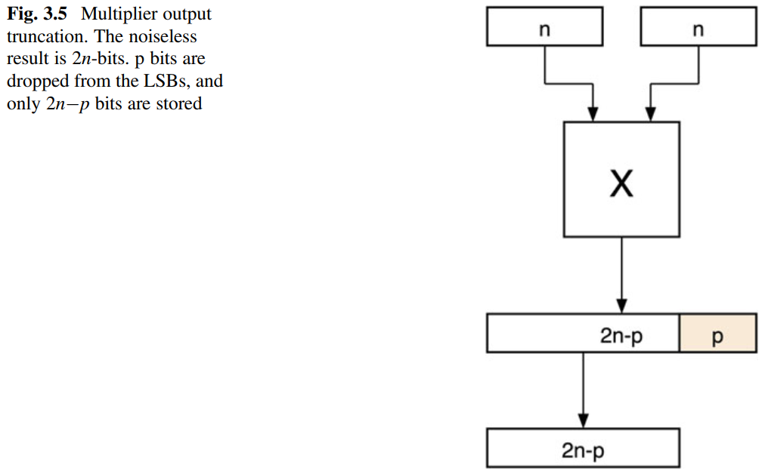

How is this done?
assume we have generated two $n-bit$variables $a$and $b$as we explained in section 3.2. The procedure is as follows:
$$c_noiseless=a×b$$
$$c_trunc =c_noiseless / 2^{p}$$
$$c_trunc =floor(c_trunc)$$
Notice that $a$and $b$ had the same scale, so we could multiply them. What is the error here? to calculate the error, we should subtract $c_trunc$and $c_noiseless$. However, again, don’t forget that they are now at different scales. Thus:
$$error=c_noiseless/2^{p} -c_trunc$$
or:
$$error=c_noiseless -c_trunc*2^{p}$$
Which is correct? both! it depends on where you place the binary point. But to have a meaningful metric for the impact of quantization, we find a ratio rather than an absolute value for noise. This ratio is the Signal-to-Quantization-Noise Ratio (SQNR), which is the ratio between the power of the signal, in this case the noiseless signal, and the power of the quantization noise. This can be calculated as:
$$SQNR=\frac{{\left(c_noiseless\right)}^{2}}{{\left(c_noiseless -c_trunc*2^{p}\right)}^{2}}$$
You can check el nos el tany men page 61 w page 62 for an example (not required for the course).
Which of the following multiplication operations really requires a multiplier?
$$c_{1}=12×5;$$
$$c_{2}=7×a;$$
$$c_{3}=a×b;$$
Answer:
$c_{1}$ is nothing but a constant-valued register, it doesn’t need a multiplier at all. $c_{2}$ needs a constant multiplier, which is nothing but adders and shifters. Specifically:
$$c_{2}=\left(4+2+1\right)×a=4a+2a+a=2^{2}a+2^{1}a+2^{0}a=\left(a≪2\right)+\left(a≪1\right)+a$$
$4a$ is shifting to the left by 2 positions and $2a$ is shifting to the left by 1 position. Thus, the operation is nothing but adders and shifters.
$c_{3}$ is the only multiplication operation that really requires a full multiplier since the two operands are variables.
Sections 3.5 3.7 are not covered in the course, you can read them. Section 3.8 is already covered in chapter 8, fa kefaya enak tezaker chapter 8.

3.9 Cost and Performance of Arithmetic
One way to implement any complicated function is using a LUT. For example, assume we want to implement $\log_{10}{(x)}$ for $x=1:10$. This is shown below. Notice that $x$can only take values from $1$to $10$ since it is used as an address.
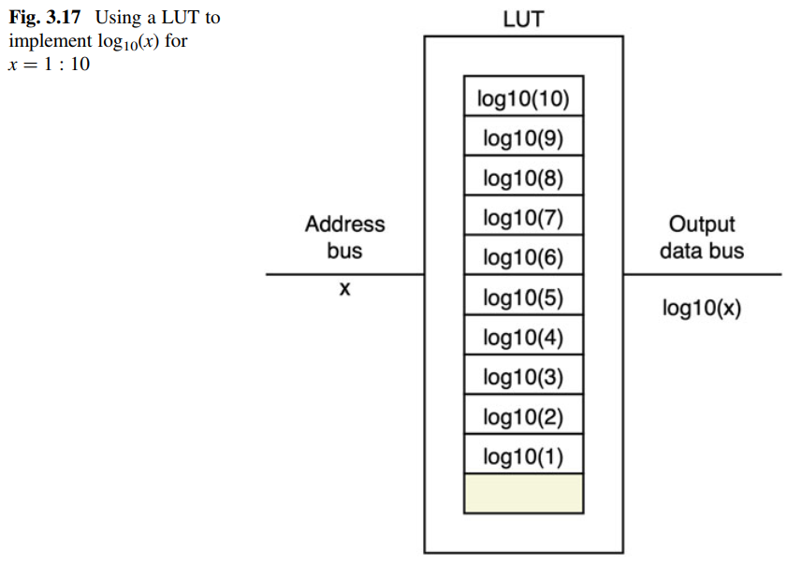
However, this might not be the case for $x$. For example, $x$might be taking the values of angles. In this case, we would need a decoder block between $x$and the LUT so that it maps the angles values to addresses. An example of a sine function is shown below.
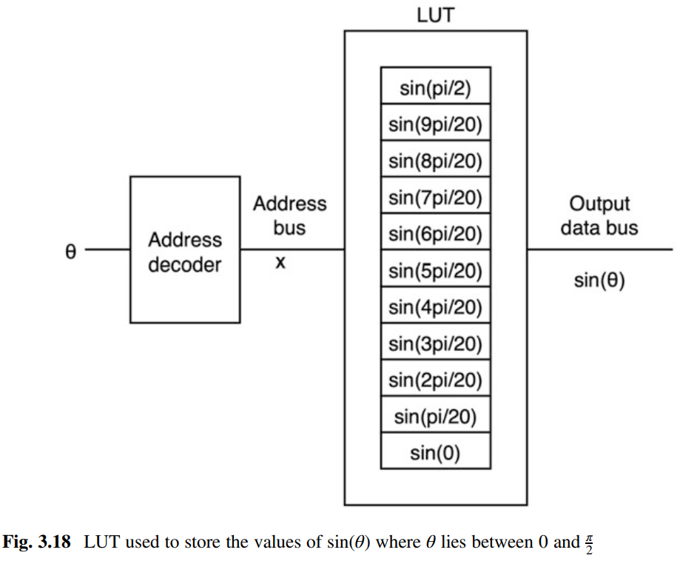
5aly balak enena 3amleen 7araka zakeya hena w heya enena me5azeneen el values beta3et el sine wave el fi awel quarter bs, ba2y el sine wave mesh me5azenenha. Leeh? la2en fih symmetry fel sine wave, fa momken ne5azen values mo3ayana bs wel address decoder yetsaraf be zakaa2. Masalan, $\sin\left(\frac{pi}{20}\right)$ heya heya $sin⁡(pi-\frac{pi}{20})$. Fa mesh mestahla ne store el etneen, la2 e7na ne store $\sin\left(\frac{pi}{20}\right)$, w lw el address decoder galo $\frac{pi}{20}$ aw galo $pi-\frac{pi}{20}$ yetala3 address 1.
In pages 84 & 85, fih 2 division algorithms momken tbos 3leehom.

Chapter 8
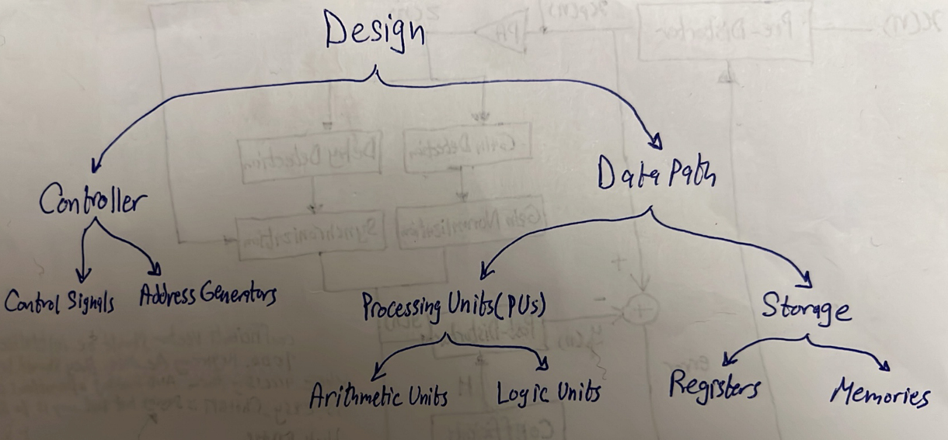
Figure 8.1 shows a flowchart for the adaptation of algorithms to hardware. This is very different from the design flow described in most hardware design books. In fact, the output of the design flow in Fig. 8.1 is the input to the traditional hardware design flows (ASIC or FPGA).
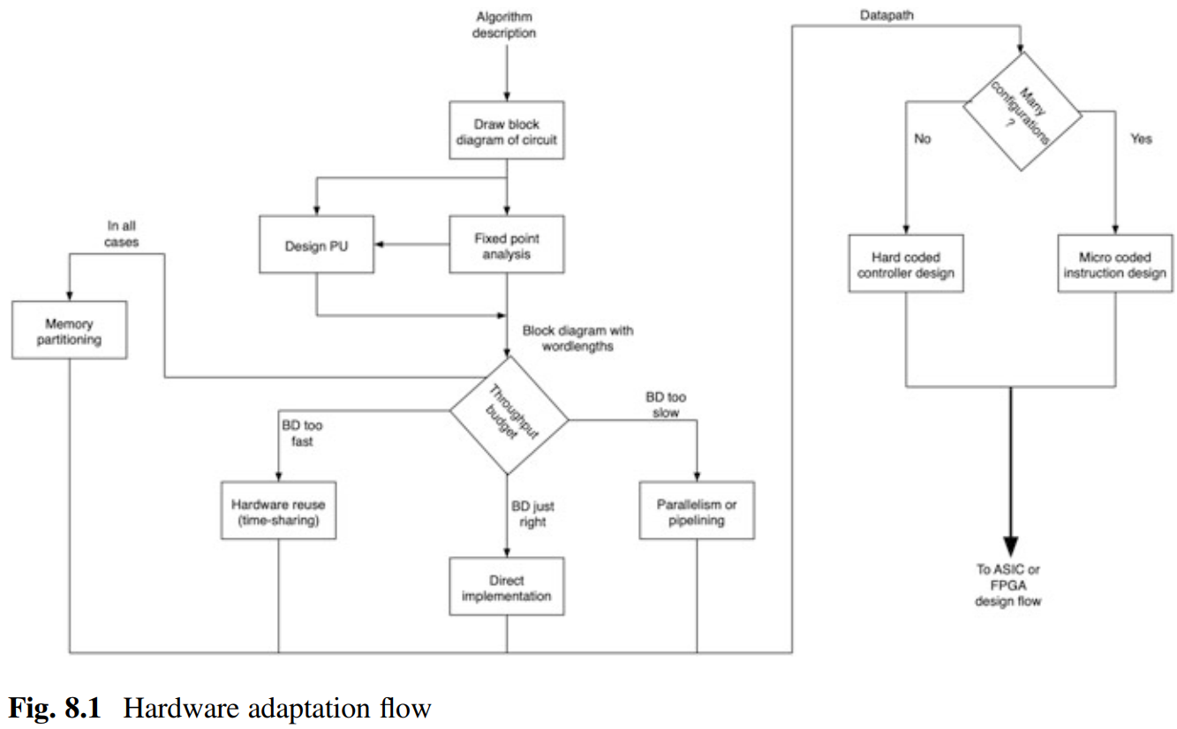
(Ana taba2t el steps el gaya de bel milli 3al pre-distorter block w 3amel documentation le kol 7aga fi file “My_Franco_Documentation” el fi folder el GP, momken te2rah lw 3ayez example ezay tetaba2 el steps el gaya de).
Step 1: draw a block diagram: we rarely rely on the block diagram to directly realize hardware, but it is an important reference point.
Step 2: determine the Processing Units (PUs) you need (e.g. MAC units, complex multipliers, etc.). Try to optimize as much as possible in each PU because they are used many times in the design, so a small optimization makes a great contribution.
Step 3: fixed-point design: in general, deciding the size of PUs requires trial and error. You should do so on MATLAB and that's why you should first select an architecture for all the blocks so that you can simulate them on MATLAB. Notice that it is normal that different PUs have different-sized multipliers and adders. (hint: take a look at the size of the DSP slices on the target FPGA, thy might help you decide).
Step 4: direct implementation: the easiest way to implement a design is to take its block diagram and realize it so that every block in the diagram has a corresponding PU in hardware. The result is a fully parallel expanded design that we call a direct implementation. So, each PU has only one task to do, no PU is used to carry out more than one task. Then, you should calculate the total number of resources that you would need to carry out all possible operations in parallel. You will accordingly calculate the number of resources required in this case of direct implementation.
Step 5: optimization: the next step is to start optimization. This usually involves looking for constants in the block diagram and realizing which of these constants introduce a special case to the arithmetic in the PUs. For example, multiplying by a constant number can be done using adders and shifters instead of using multipliers. This way, you can reduce the number of multipliers you need. Notice that we are only optimizing the resources that we have already placed for direct implementation, we are not resource sharing or pipelining here.
Step 6: throughput budgeting: in this step, we calculate the required throughput (usually expressed in MSps: Mega Samples Per Second) from our block as well as the throughput currently offered by the direct implementation. To calculate the required throughput, this requires information about the position of the design in the overall system. To calculate the throughput currently offered by the direct implementation, this requires familiarity with the implementation platform which will determine the operating speed of the PUs. Fanta el mafrood men el 5atwa de ta7dedan tetla3 kateb 7aga zy keda:
- System requirements: DPD at the rate of $368.64$MSps.
- PU Speed: multipliers operating at $3$ns – adders operating at $2$ ns.
(check section 8.8 for an example). Then, from the direct implementation, you will end up with a circuit that:
- has exactly or slightly higher throughput than required. In such case, direct implementation can be used.
- has a throughput lower than what we need. In such case, parallelism and pipelining are the solution. But isn't "parallelism" the same thing as "direct implementation"? no, by direct implementation we mean using parallel PUs to implement the algorithm so that each PU does only one task. By parallelism, we mean having parallel instances of the whole block diagram itself (e.g. 2 FFTs). Regarding pipelining:
  - We always pipeline between PUs (PU is like a butterfly unit or a MAC unit).
  - We scarcely pipeline inside a PU.
  - We never pipeline inside an arithmetic circuit (e.g. adder or multiplier).
- is bigger and has a throughput higher than what we need. In such a case (which is the most common case), then resource sharing is the solution. The level of time sharing available is $m=\frac{available throughput from direct implementation}{required throughput}$. That is, we can use $\frac{1}{m}$ of the PUs in the direct implementation and still achieve the required throughput. However, the deeper the order of time sharing, the more complicated control becomes. So, you will most probably calculate $m$and back off from the maximum possible order of reuse to an order that makes sense in terms of the function of the circuit. It is very important to notice that using time sharing would lose us the optimizations we did in step 5. Why? imagine you found a multiplier in the direct implementation that multiplies by a constant $0.75$ and you decided to replace it by a constant multiplier which consists of just some adders and shifters. Now in time sharing, this same multiplier does not necessarily multiply by $0.75$every clock cycle, it now has different input operands each clock cycle. In this case, you need to use a full multiplier not a constant multiplier. Fa men el a5er 5aly balak en el throughput el enta kont 7asbo fi awel el step de kan based on el optimized PUs. Now you will not be using these optimized PUs, so be careful when you recalculate the throughput after time sharing to use the delays of the non-optimized PUs.
You can think of the three options as:
Direct Implementation $→$number of PUs is equal to the number of operations.
Parallelism $→$number of PUs is more than the number of operations.
Resource sharing $→$number of PUs is less than the number of operations.
Notice that you can use a combination of the three techniques. For example, you can use resource sharing with pipelining or direct implementation with pipelining.

Example:
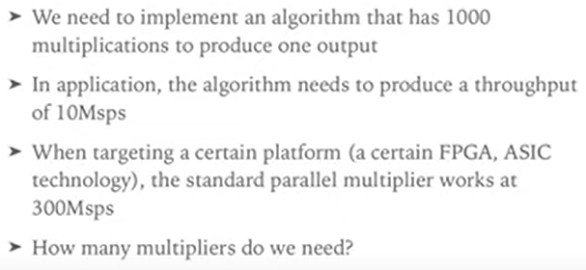
Answer:
The algorithm requires a throughput of 10 mega samples every second, and every sample requires 1000 multiplication operations. Thus, it is required to carry out 10 * 1000 = ${10}^{10}$ multiplication operations every second. One multiplier can carry out 300 * ${10}^{6}$ multiplication operations every second. Thus, we need $\frac{{10}^{10}}{300*{10}^{6}}=33.3→34$multipliers.
This sums up sections 8.1 to 8.8.
You need to read sections 8.9 to the end la2en kolohom etshara7o (I think you can skip section 8.12 mola5aso en awel noo3 men el controllers howa el FSM el e7na 3arfenha 3ady 5ales).
Example:
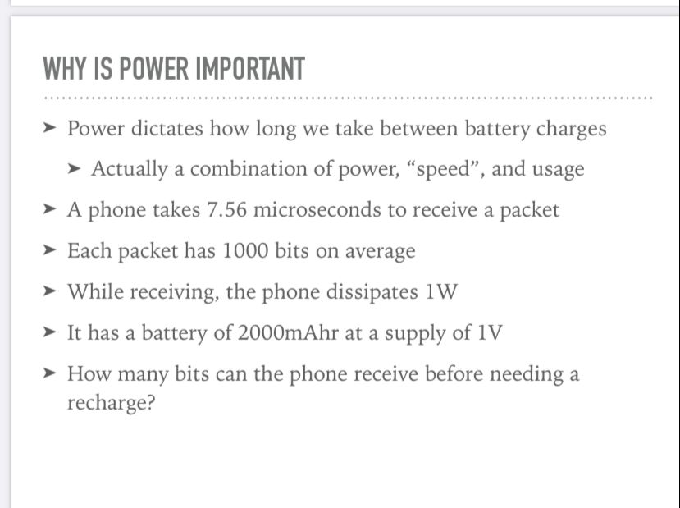

Answer:
